Emergency Response Scenario – Zoo Trip (injury)
(Years 5 &6 or Year 9, 2 buses 60 students plus teachers and parent supervisors)
The bus has just pulled into the car park at the zoo. A student spots a friend from another school across the car park, rushes off the bus, runs across the car park to meet their friend, gets hit by a car, and is in too much pain to get up.
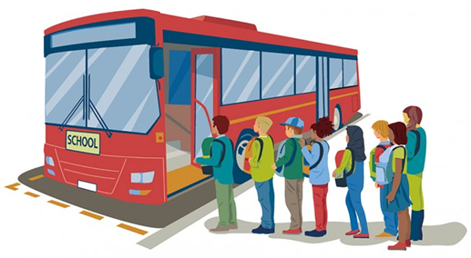
Task
What steps would you take and in what order to manage this? Refer to your school emergency response plans and processes. Be ready to share your learning

Emergency Response Scenario – International Sports Trip (lost passport)

Secondary school sports tour to Argentina. Visiting the Iguazu Falls required each student to carry their passport through border control into Brazil. Tour leader had kept all passports safe on behalf of students to that point. One student puts their passport in the chest pocket of their travel uniform shirt, leans over the railing overlooking the falls to get a better view and the passport falls in! (True story!). No-one speaks Spanish apart from the Argentine tour guide.
Task
What steps would you take and in what order to manage this? Refer to your school emergency response plans and processes. Be ready to share your learning
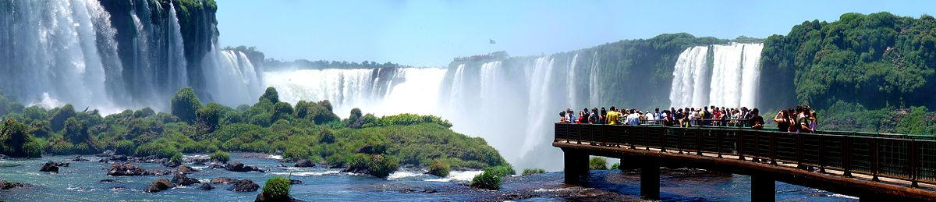
Emergency Response Scenario – Kayaking (drowning)
A group of ten y10 students, two y13 leaders and one teacher/competent kayaker are kayaking on a large pond. It is an open unsheltered location and the pond is murky but not deep.
Students have been playing canoe polo at the end of their session. One student has tipped out of their kayak trying to get away from pursuers and struck their head hard on a submerged rock. They have been knocked unconscious and are submerged under the kayak. Despite best efforts to rescue them they have been under the water too long and can’t be resuscitated.
Task
What steps would you take and in what order to manage this? Refer to your school emergency response plans and processes. Be ready to share your learning
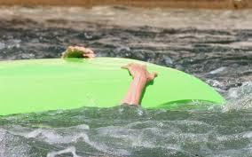

Emergency Response Scenario – Kayaking (hypothermia)
A group of ten y10 students, two y13 leaders and one teacher/competent kayaker are kayaking on a large pond. It is an open unsheltered location and the pond is murky but not deep.
The air temperature is 10ºC and water temperature 12ºC. A cold southerly breeze of 15 knots is blowing. Students have been told to wear thermals and a windproof jacket. One student has tipped out early in the session and while they were wearing a windproof it was not known that they had no thermals on. The student has not indicated they are cold. Eventually they go very quiet and slowly paddle to the side of the pond some distance from the van where they collapse but remain conscious.
Task
What steps would you take and in what order to manage this? Refer to your school emergency response plans and processes. Be ready to share your learning
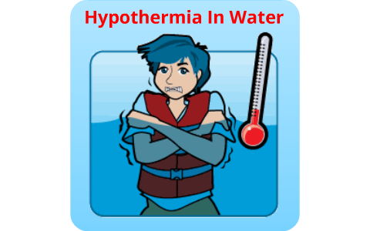

Emergency Response Scenario – School Camp (illness)
A student has been uncharacteristically quiet and less energetic during the day and has complained of a headache. It is now ‘free time’ before dinner and another student informs you they are now in bed shivering with a splitting headache, looking very pale and wanting to throw up but they have begged their friend not to tell because they don’t want to go home.
Task
What steps would you take and in what order to manage this? Refer to your school emergency response plans and processes. Be ready to share your learning

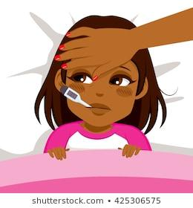

Emergency Response Scenario – School camp (misconduct)
Despite repeated warnings and being reminded of the rule, one of the girls has once again gone into a boy’s cabin, this time when one of them was changing. She has been uncooperative on several occasions during the day, choosing not to follow instructions at times and disrupting others’ participation and fun. Teachers have used the usual strategies for such behaviour and have had enough. There is concern that she cannot be trusted to follow instructions without question when safety is an issue.
Task
What steps would you take and in what order to manage this? Refer to your school emergency response plans and processes. Be ready to share your learning

Emergency Response Scenario – Campout Cooking (burn)
A group of 35 students, 6 student leaders and 3 teachers are camping in a bush clearing 10 mins walk from the main camp. It is 8.45pm and students are about to have supper.
A teacher is preparing a 20L pot of milo on a large burner. A group of students are playing spotlight and one student runs into the forbidden cooking area and trips on the cooker knocking the hot milo onto themselves. They have serious burns from the cooker and also the milo. They are screaming in pain and this is causing other students to become upset, a friend has become hysterical.
Task
What steps would you take and in what order to manage this? Refer to your school emergency response plans and processes. Be ready to share your learning

Emergency Response Scenario – Tramping (injury)
A group of 35 students, 6 student leaders and 3 teachers are on a five hour tramp in the Hunua Ranges. It is late autumn, the temperature is 15ºC, the forecasted rain has just started and looks like it will settle in. The group is well-equipped.
Four of the students were walking on a small bridge when it gave way. They fell 2 metres into a small stream. The first student is unconscious, the second student looks like they have broken their ankle, the third has a large gash on their thigh which is bleeding heavily and the fourth appears to be fine. The rest of the group are visibly shocked by what has happened.
Task
What steps would you take and in what order to manage this? Refer to your school emergency response plans and processes. Be ready to share your learning

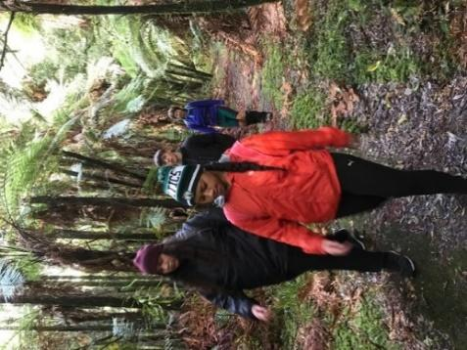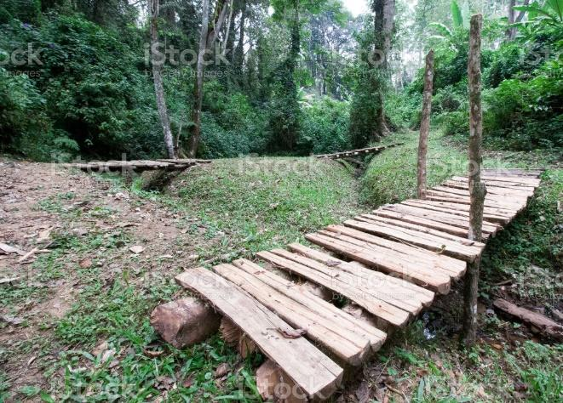

Emergency Response Scenario – Tramping (lost person)
When you do a count of students at the end of your hiking track you notice that a student is missing. A friend pipes up and tells you they fell behind on the track to go to the toilet and said they would catch up. You still have another 10 minute walk out to the carpark. Its late afternoon early April and the temperature is falling after a warm day. Students are equipped for a day tramp.
Task
What steps would you take and in what order to manage this? Refer to your school emergency response plans and processes. Be ready to share your learning
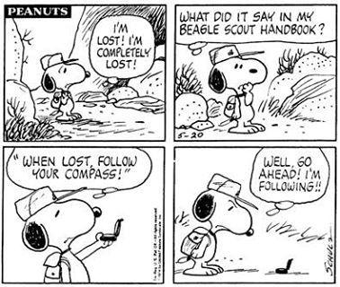

Emergency Response Scenario – Mountain Biking (injury)
Group of 18 students and 2 teachers are riding on a cycle trail. One student has been following too closely and doesn’t react fast enough to the person in front braking down the hill. Both come off, one has grazes on their left knee and elbow, with a cut that is bleeding on the knee. The other is moaning in pain and holding their arm complaining of severe pain around the wrist area and have bruising on the palm of that hand.
Task
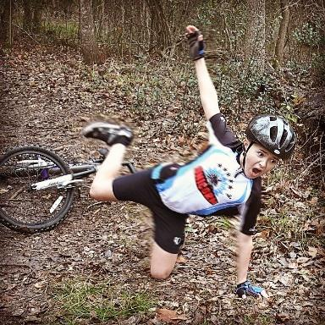
What steps would you take and in what order to manage this? Refer to your school emergency response plans and processes. Be ready to share your learning

Questions to consider – Emergency response
- What did you do first?
- What roles did you allocate?
- What information did you need?
- What course of action did you take?
- Who did you communicate with? (How and when? How did you deal with cell phones?)
- How did you resolve the situation?
- Did you discuss, debrief, offer support, record, report and review the incident?

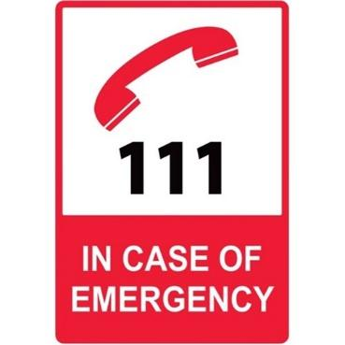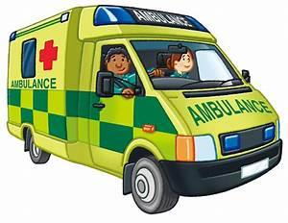

Refer to EOTC Guidelines Tool Kit - Sample Form 14 and 15

